Northamptonshire Music and Performing Arts Trust (NMPAT)
NMPAT is an independent Charity which for over 50 years has provided educational experiences in music and performing arts to the children and young people of the County of Northamptonshire. One of their main roles is to provide opportunities for young musicians to play in ensembles and the bands demonstrate that opportunity at the highest level. Today over 20,000 people take the opportunity to be part of the journey that takes them from the first lessons on an instrument, through junior groups to our senior County Ensembles. The Trust offers the opportunity for young musicians to be inspired, to be nurtured and to excel in the field of music and performing arts.
The County Youth Concert Band and County Youth Brass Band are two of the flagship groups of the Trust and are amongst the 27 County ensembles that rehearse weekly. Membership of the bands is by annual audition. Over 800 young musicians audition annually to be a member of one of our ensembles and every two years these senior bands travel to Europe to perform in concerts to share their musicianship and love of music making.
Previous tours have included:
2019 Poland: Zakopane, Krakow, Mielec, and Przemysl
2017 Italy: Perugia and Ravenna
2015 Czech Republic and Slovakia: Prague and Bratislava
2013 Spain: Burgos and Valladolid
2011 Germany: Leipzig and Berlin
2009 Hungary: Budapest
2007 Poland: Wroclaw, Przemysl and Warsaw
2005 Italy: Lake Garda
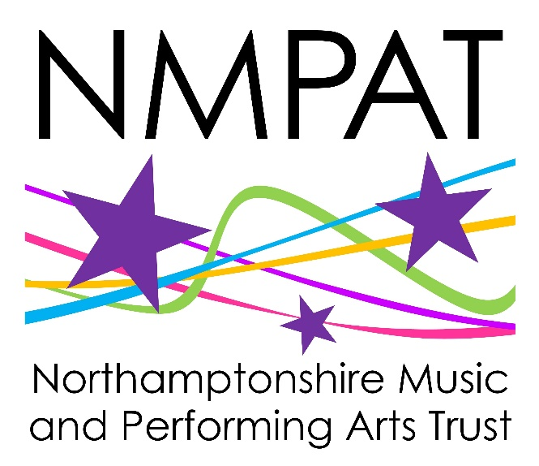
2003 Austria: Vienna and Salzburg
2001 Poland: Krakow and Zakopane

Office@NMPAT.co.uk
www.NMPAT.co.uk
WWW.Facebook.com/NMPAT
WWW.Twitter.com/NMPATrust

Northamptonshire County Youth Concert Band
The County Youth Concert Band has the reputation of being one of the leading youth wind orchestras in the Country with a reputation for presenting the most challenging of contemporary repertoire for Wind Orchestra. They have a formidable record of success at the National Concert Band Festival and National Festival of Music for Youth where they have been awarded more top performance honours than any other band in the country.
They have been featured as recording artists by leading publishers Studio Music and R Smith and Company and have worked with many of the leading composers for the medium, giving several notable British and World Premieres.
Peter Smalley: Musical Director County Youth Concert Band
Peter Smalley is a trumpet and cornet player who studied in Birmingham before entering the teaching profession. Outside of teaching he has worked as a conductor, composer and arranger with a portfolio of over 40 published titles and performances, publications, recordings and broadcasts from Chicago to Osaka. He came to work in Northamptonshire in 1993 as Head of Brass and Percussion before becoming Chief Executive in September 2012.
He has been the conductor of the County Youth Concert Band since 2000 and with them has been a regular performer at the Music for Youth National Festival, has won 40 top Awards at the National Concert Band Festival. He has appeared with them at The Royal Albert Hall, Royal Festival Hall, Symphony Hall Birmingham, and in some of the major cultural centres of Europe: Salzburg, Berlin, Budapest, Vienna, Leipzig, Verona, Venice, Krakow and Warsaw.

Northamptonshire County Youth Brass Band
The County Youth Brass Band was the first countywide ensemble in Northamptonshire and so can justifiably claim to be the origin of the whole Music and Performing Arts Trust. Formed in 1969, some of the founder members have become members of staff and retain a connection with the organisation and many former members have become leading professional brass players in all genres of music.
The Band has a long tradition of success at the National Youth Brass Band Championships and are previous holders of the title of Champion Youth Brass Band of Great Britain. In 2014 represented England at the inaugural European Youth Brass Band Championships in Perth Scotland.
Bradley Turnbull: Musical Director of the County Youth Brass Band
Brad Turnbull is a trombonist and a former member of the Northamptonshire County Ensembles. He was a member of the County Youth Orchestra and County Youth Concert Band. After studies on Trombone at the Royal Academy of Music in London, he returned to the County to join the teaching staff. In 2005 he became the director of the County Youth Brass Band, only the 6th director in their 53 year history and already the second longest incumbent.
With the band Brad has won many national honours including performance awards at the National Festival of Music for Youth and National Youth Brass Band Championships and third place at the European Youth Brass Band Championships. He has appeared with them at the prestigious Schools’ Prom in the Royal Albert Hall, London.

